**Blinking an LED**

**Project Overview**

This project demonstrates the basic functionality of controlling an LED using an Arduino. The LED will blink on and off at a regular interval.

**Materials Required**

1. Arduino Uno (or any compatible board)
2. LED (any color)
3. Jumper wires
4. USB cable for Arduino

Description of Connections:

**Circuit Diagram**

* Connect the **long leg (anode)** of the LED to **digital pin 13** of the Arduino.
* Connect the **short leg (cathode)** of the LED to one leg of the resistor.
* Connect the other leg of the resistor to the **GND pin** on the Arduino.

**Steps to Build**

1. **Connect the Components**:
   * Place the LED on the breadboard.
   * Connect the anode of the LED to pin 10 and cathode of LED to GND of the Arduino using a jumper wire.
2. **Write the Code**:
   * Open the Arduino IDE.
   * Copy and paste the code provided below.
3. **Upload the Code**:
   * Connect the Arduino to your computer using the USB cable.
   * Select the correct board and port in the Arduino IDE (Tools > Board and Tools > Port).
   * Click the **Upload** button.
4. **Observe the Output**:
   * The LED will blink on and off at 5-second intervals.

**Code for Blinking LED:**

// Define the LED pin

const int ledPin = 10;

void setup() {

// Set the LED pin as an output

pinMode(ledPin, OUTPUT);

}

void loop() {

// Turn the LED on

digitalWrite(ledPin, HIGH);

delay(5000); // Wait for 5 seconds

// Turn the LED off

digitalWrite(ledPin, LOW);

delay(5000); // Wait for 5 seconds

}

For better view/understanding refer the code file.

**Code Explanation:**

1. **Pin Configuration:**
   * pinMode(ledPin, OUTPUT);: Sets pin 13 as an output pin.
2. **Turning the LED On and Off:**
   * digitalWrite(ledPin, HIGH);: Turns the LED on.
   * digitalWrite(ledPin, LOW);: Turns the LED off.
3. **Delay:**
   * delay(1000);: Pauses the program for 5000 milliseconds (5 second).

**Photos and Video of the Circuit:**

**LED_OFF:**

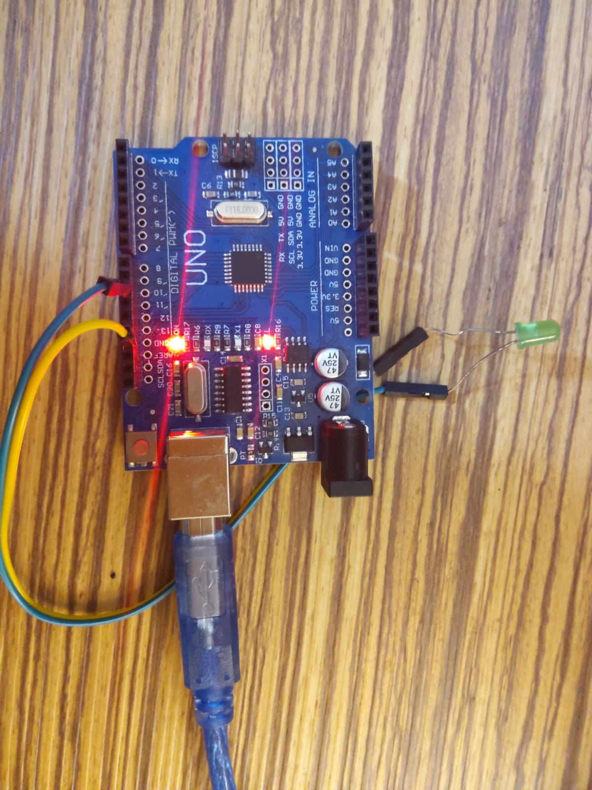

**LED_ON:**

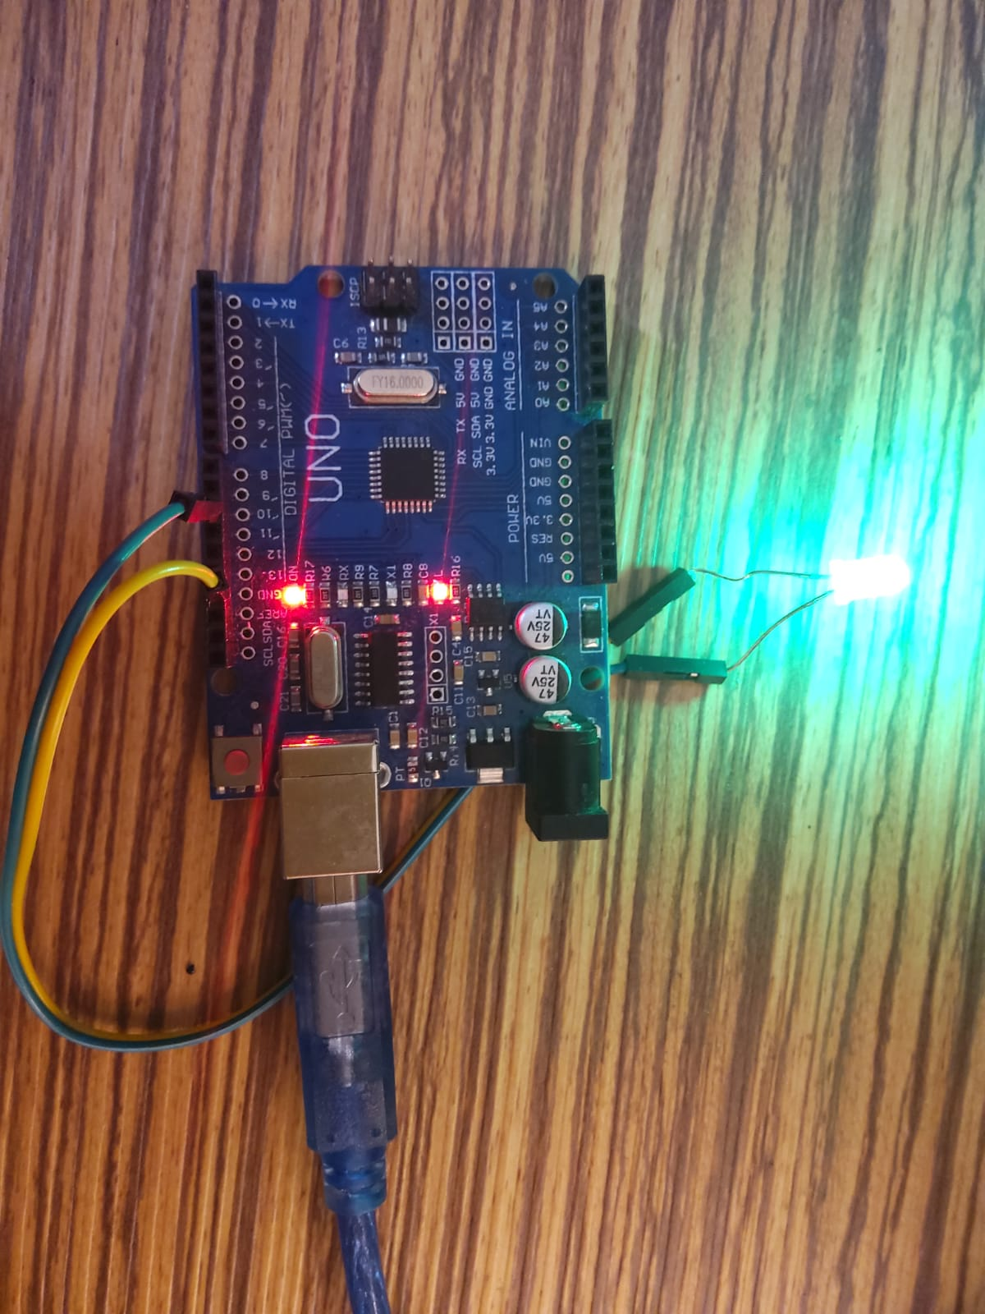

For video refer the repo